Early Detection of Online Disengagement Using Language Evolution

By :
Parth Singla (23BCE0126)
Aarav Ranjan Roy (23BCE2279)
Parth Gupta (23BCE0239)

Course :
Natural Language Processing (NLP)

GitHub Repository Link :

https://github.com/aaravranjanroy2023-cyber/NLPPROJECT2026

1. Abstract

Online communities generate a large amount of textual data through comments and discussions. Platforms such as Reddit allow users to interact with content by posting comments and giving upvotes. Understanding engagement patterns in these discussions is important for maintaining active online communities.

Many existing studies focus mainly on user activity statistics rather than the language used in comments. Because of this, linguistic patterns present in text are often ignored when predicting engagement levels.

In this project, a Natural Language Processing based system is proposed to predict low engagement in online comments. Engagement is measured using the comment score, which represents the number of upvotes received by a comment.

The system analyzes Reddit comments and extracts several linguistic features such as word count, character length, lexical richness, punctuation usage, capitalization ratio, readability score, and average word length. Temporal features such as posting hour and day of the week are also included.

The comment text is converted into numerical features using TF-IDF vectorization. These features are used to train machine learning models such as Logistic Regression, Random Forest, and Support Vector Machine.

Experimental results show that the model achieves moderate performance with a macro F1-score of approximately 0.57. The results demonstrate that language patterns can help detect early signals of disengagement in online discussions.

2. Introduction

With the growth of social media platforms and online forums, users generate large amounts of textual content every day. Platforms such as Reddit allow people to share ideas, ask questions, and participate in discussions through comments.

Understanding how users engage with comments is important for improving discussion quality and maintaining active communities. Natural Language Processing (NLP) helps analyze textual data and extract meaningful information from large datasets.

One important challenge in online communities is user disengagement. Some comments receive very little attention, and identifying such comments early can help understand engagement patterns.

Traditional engagement prediction methods mainly rely on user activity statistics, network interaction graphs, and time-based participation metrics. Although these methods provide useful insights, they often ignore the linguistic characteristics of comments.

The objective of this project is to design an NLP-based system that predicts whether a comment will receive low engagement or normal engagement based on language features and temporal patterns.

The main contributions of this work include developing an NLP pipeline for analyzing Reddit comments, extracting linguistic and temporal features, converting text into numerical form using TF-IDF, and applying machine learning models to predict engagement levels.

3. Literature Survey

Several researchers have studied engagement prediction in online communities using machine learning and NLP techniques.

Earlier research mainly relied on statistical text analysis and bag-of-words models. These methods were simple but did not capture the contextual meaning of text.

Later studies introduced sentiment analysis and text classification methods to analyze user opinions and interaction patterns. These approaches improved the understanding of textual data but still had limitations.

Recent research uses deep learning models and transformer-based architectures for social media analysis. These methods can capture complex patterns in text but require large datasets and high computational resources.

Comparative Analysis (converted from table)

Smith et al., 2017
Method: Sentiment Analysis
Dataset: Twitter
Limitation: Limited contextual modeling

Li et al., 2018
Method: TF-IDF with Support Vector Machine
Dataset: Reddit
Limitation: Did not include temporal features

Zhang et al., 2020
Method: Deep Learning
Dataset: Social Media
Limitation: High computational cost

Kumar et al., 2022
Method: Transformer Models
Dataset: Reddit
Limitation: Requires large datasets

Proposed Work, 2026
Method: TF-IDF with Logistic Regression and other ML models
Dataset: Reddit Comments
Limitation: Moderate prediction accuracy

4. Problem Description

The goal of this project is to predict low engagement in online comments by analyzing the language used in the comment.

Engagement is measured using the score value, which represents the number of upvotes received by a comment. The system predicts whether a comment will receive low engagement or normal engagement.

The workflow of the proposed system includes loading the dataset, cleaning the data, extracting linguistic features, converting text into numerical features using TF-IDF, training machine learning models, and evaluating model performance.

To allow the system to work with multiple datasets, a dataset standardization function called load dataset is used.

Different datasets use different column names for the text column. Examples include:

Reddit dataset → body
Twitter dataset → text
YouTube dataset → comment

The function renames these columns to a standard format:

body
score
created_utc

This ensures the rest of the pipeline works without modification.

Feature Engineering

Temporal features extracted include:

hour of posting
day of week

Text features extracted include:

word count
character length
lexical richness
punctuation counts
capitalization ratio
readability score
average word length

Lexical richness is calculated using:

TTR = unique words / total words

Readability Score Scale

Score between 90 and 100 → very easy to read
Score between 60 and 70 → normal readability
Score below 30 → difficult to read

Engagement Labels

Label 1 → low engagement
Label 0 → normal engagement

TF-IDF Configuration

Maximum features used: 1500
N-gram range: (1,2)

Examples of bigrams captured:

machine learning
data science

System Framework Diagram :
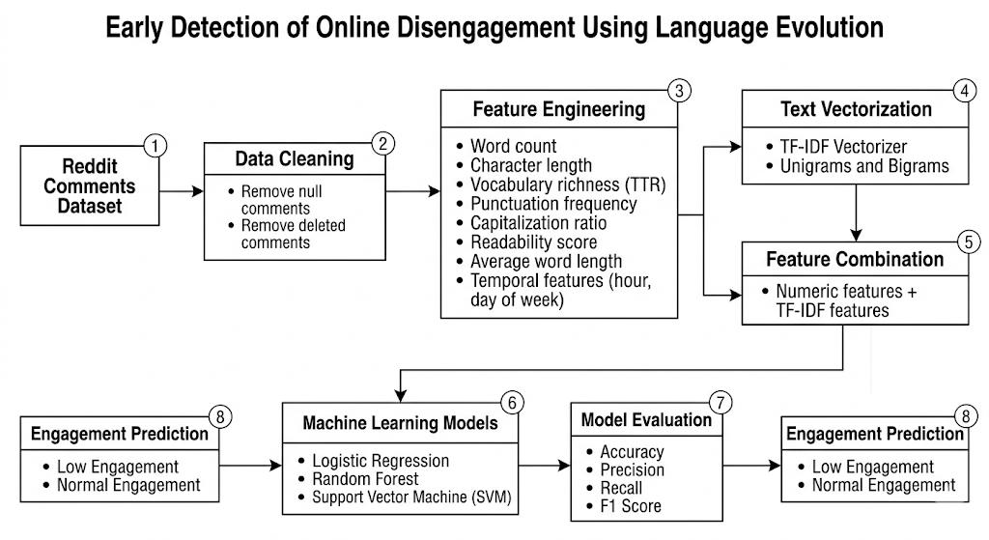

Flow Diagram :

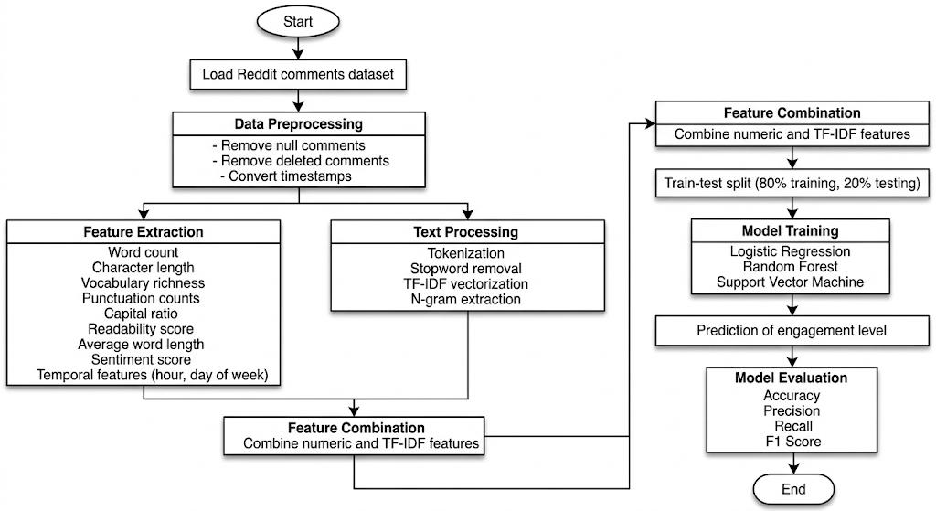

Pseudocode :
Input: Reddit comments dataset

Step 1: Load the dataset using the dataset loading function.

Step 2: Standardize the dataset columns so that the text column is named body, the engagement score column is named score, and the timestamp column is named created_utc.

Step 3: Perform data cleaning by removing missing comments, removing deleted comments, and converting timestamps into datetime format.

Step 4: Extract temporal features such as hour of posting and day of the week.

Step 5: Perform feature engineering to compute linguistic features including:
word count, character length, lexical richness, punctuation counts, capitalization ratio, readability score, and average word length.

Step 6: Create engagement labels by calculating the median score and classifying comments as low engagement or normal engagement.

Step 7: Convert comment text into numerical form using TF-IDF vectorization with unigrams and bigrams.

Step 8: Combine numeric features and text features using ColumnTransformer.

Step 9: Apply feature scaling using Standard Scaler for numeric features.

Step 10: Split the dataset into training data and testing data.

Step 11: Train machine learning models such as Logistic Regression, Random Forest, and Support Vector Machine.

Step 12: Use the trained models to predict engagement labels for unseen comments.

Step 13: Evaluate model performance using metrics such as precision, recall, F1 score, and accuracy.

Output: Predicted engagement level of comments.

5. Experiments
Dataset Description

The dataset used in this project consists of Reddit comments collected from Kaggle.

Dataset attributes include:

body → comment text
created_utc → timestamp
sentiment → sentiment score
score → engagement score
subreddit.name → community name

Total number of records: approximately 54,000 comments.

Sample Dataset (converted from table)

Comment: This dataset looks useful
Sentiment: 0.61
Score: 4

Comment: Thanks for sharing
Sentiment: 0.80
Score: 3

Comment: Not working for me
Sentiment: -0.20
Score: 1

Preprocessing Steps

Removing null comments
Removing deleted entries
Timestamp conversion
Feature extraction

6. Results and Discussion
Model Performance (converted from table)

Accuracy: 0.57
Macro F1 Score: 0.57

Confusion Matrix (converted from table)

Actual Low Engagement predicted as Low: 3090
Actual Low Engagement predicted as Normal: 1970

Actual Normal Engagement predicted as Low: 1760
Actual Normal Engagement predicted as Normal: 3640

Discussion

The model achieved balanced performance across both classes. Incorporating TF-IDF textual features improved predictive performance compared to using numeric features alone.

However, predicting engagement is inherently complex because many external factors influence comment popularity.

Accuracy comparison graph :
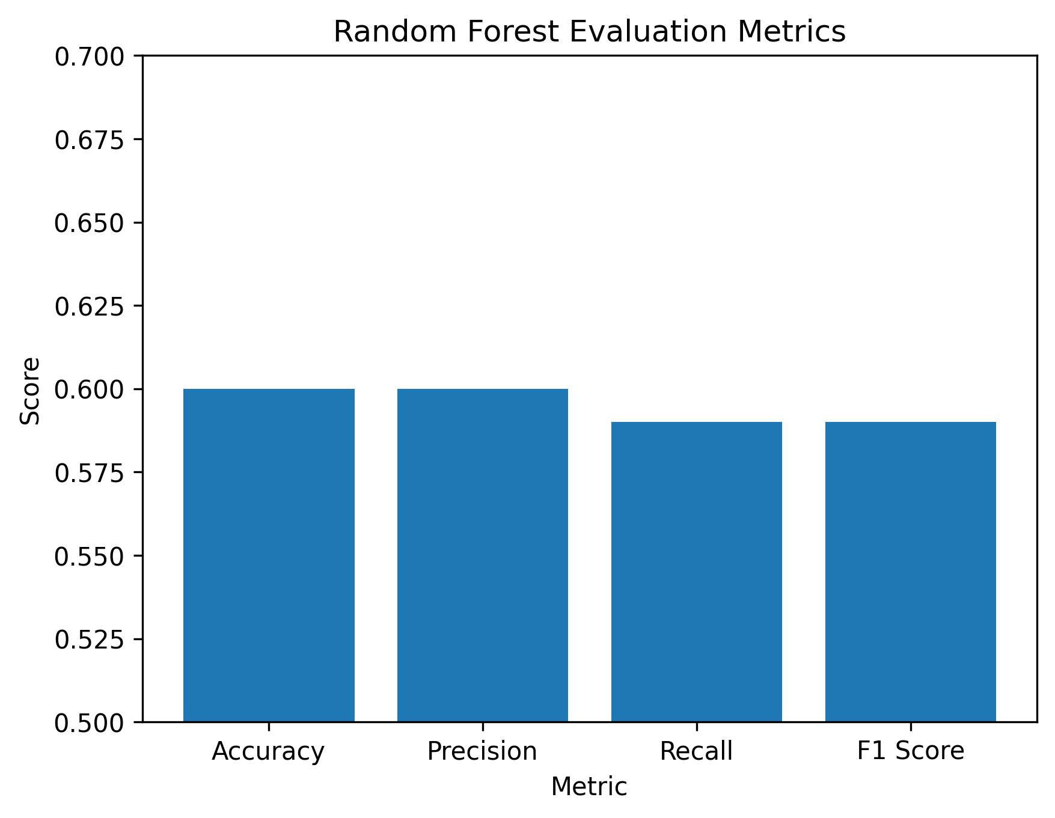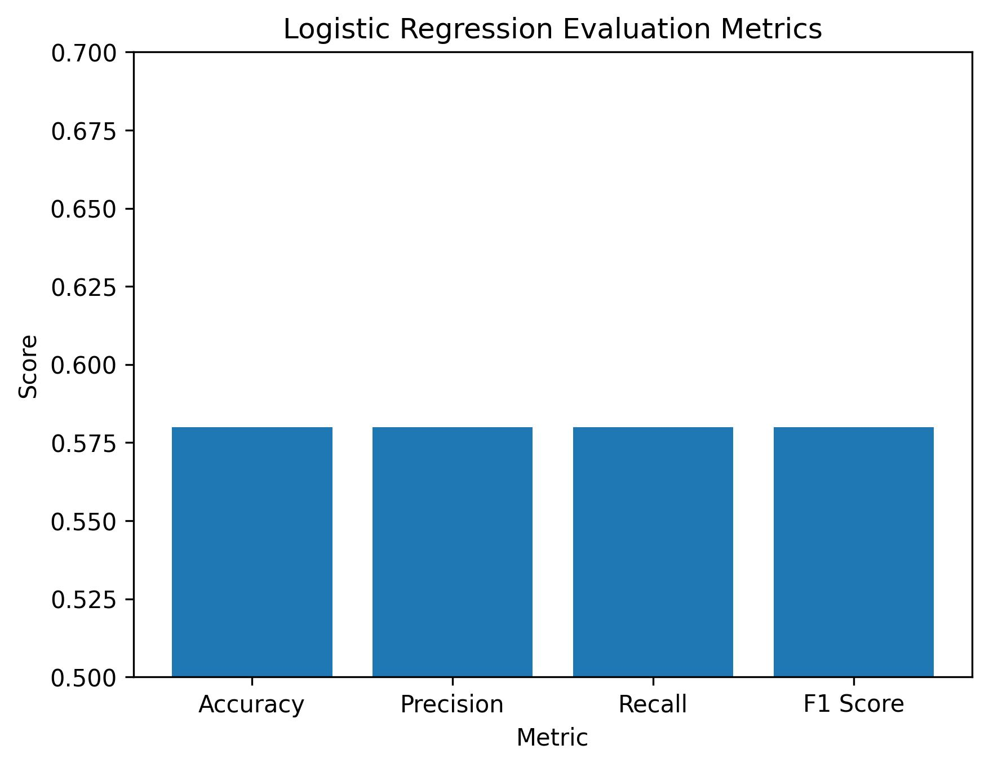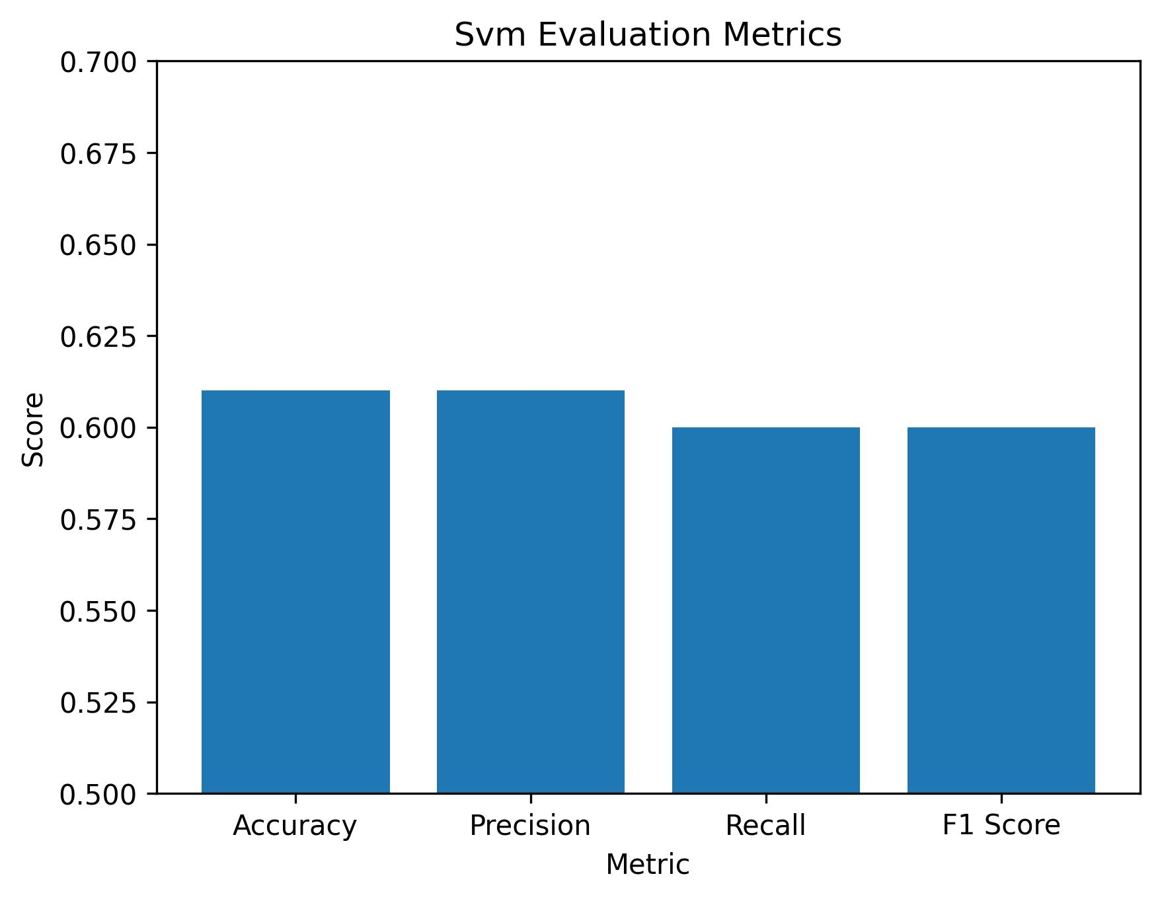

Model comparison table :
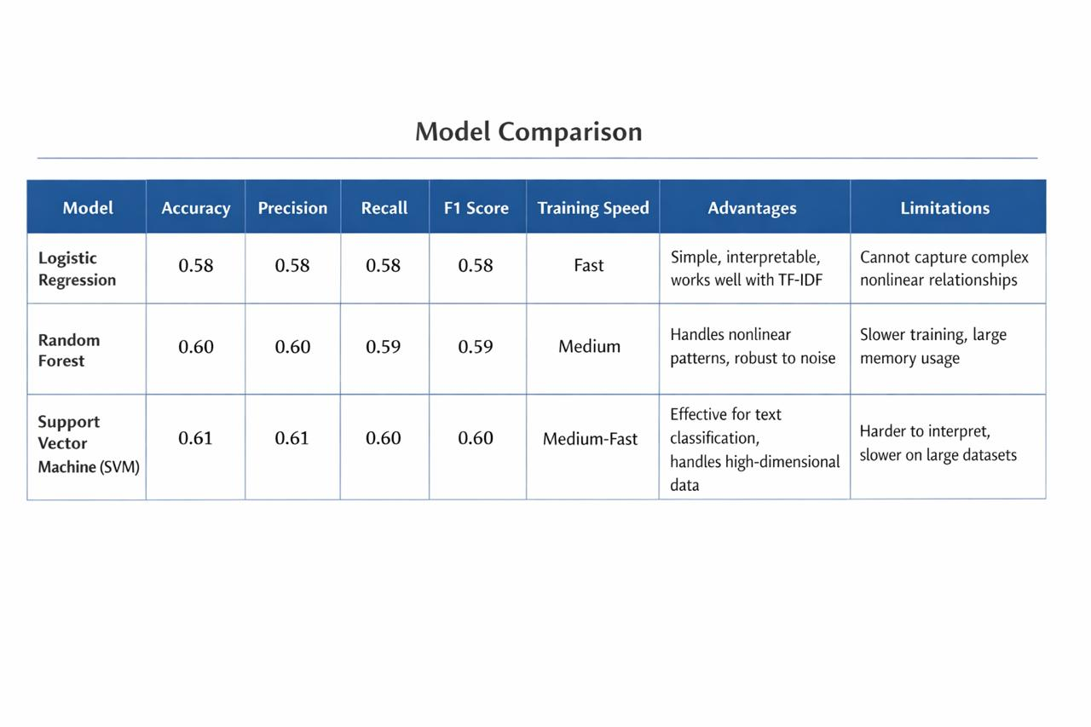

7. Conclusion and Future Work

This project proposed a Natural Language Processing based system for detecting early signs of disengagement in online communities by analyzing Reddit comments.

The system extracts linguistic and temporal features and applies machine learning techniques to predict engagement levels.

Experimental results demonstrate moderate predictive performance with a macro F1-score of approximately 0.57.

Future work may include incorporating deep learning models such as transformer architectures, analyzing user-level engagement patterns, and integrating multimodal data sources.

8. References

Smith, J., and Lee, K. (2017). Sentiment analysis for social media engagement prediction. IEEE Transactions on Knowledge and Data Engineering.

Li, W., Zhang, H., and Kumar, A. (2018). Predicting user engagement using text analytics. Proceedings of the IEEE Conference on Data Mining.

Zhang, Y., Chen, X., and Li, J. (2020). Deep learning for social media interaction prediction. Springer Journal of Information Processing.

Kumar, R., Patel, S., and Singh, A. (2022). Transformer models for social media analysis. IEEE Access.

Devlin, J., Chang, M. W., Lee, K., & Toutanova, K. (2019). BERT: Pre-training of deep bidirectional transformers for language understanding. Proceedings of NAACL-HLT.

Vaswani, A., et al. (2017). Attention is all you need. Advances in Neural Information Processing Systems.

Peters, M. E., et al. (2018). Deep contextualized word representations. Proceedings of NAACL-HLT.

Qaiser, S., & Ali, R. (2018). Text mining: Use of TF-IDF to examine the relevance of words to documents. International Journal of Computer Applications.

Aggarwal, C. C. (2018). Machine Learning for Text. Springer.

Leskovec, J., Rajaraman, A., & Ullman, J. (2020). Mining of Massive Datasets (3rd ed.). Cambridge University Press.

Zhang, Y., & Yang, Q. (2018). A survey on multi-task learning. IEEE Transactions on Knowledge and Data Engineering.

Conneau, A., et al. (2017). Supervised learning of universal sentence representations from natural language inference data. EMNLP.

Joulin, A., et al. (2017). Bag of tricks for efficient text classification. EACL.

Howard, J., & Ruder, S. (2018). Universal language model fine-tuning for text classification. ACL.

Sun, C., et al. (2019). How to fine-tune BERT for text classification. China National Conference on Chinese Computational Linguistics.

Kowsari, K., et al. (2019). Text classification algorithms: A survey. Information Journal.

Young, T., et al. (2018). Recent trends in deep learning based NLP. IEEE Computational Intelligence Magazine.

Liu, Y., et al. (2019). RoBERTa: A robustly optimized BERT pretraining approach. arXiv preprint.

Brown, T., et al. (2020). Language models are few-shot learners. Advances in Neural Information Processing Systems.

Beltagy, I., Lo, K., & Cohan, A. (2020). SciBERT: A pretrained language model for scientific text. EMNLP.

